Sarkar, Mohul (Student)

Lab 1: OSPF

Cisco CCNP

Mohul Sarkar

**Purpose:**

The purpose of this lab was to make 5 routers communicate with one another using OSPF ipv4

**Background information on lab concepts:**

OSPF and IP configuration

**Lab Summary:**

We successfully set up OSPF onto a network of five routers. We accomplished the ability to ping between one another using a single OSPF area and setting up the ip addresses accordingly.

**Lab Commands:**

router ospf [process-id]

network [ip-address] [wildcard-mask] area [area-id]

**Network Diagram with IP’s:**

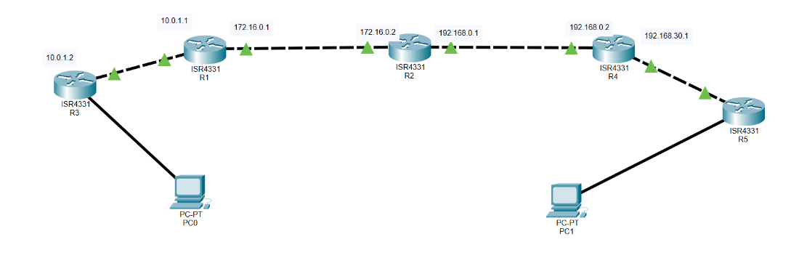

**Configurations:**

**R1:**  
interface Loopback0   
ip address 192.168.10.2 255.255.255.255  
interface Loopback1 ip address 192.168.20.1 255.255.255.255  
interface GigabitEthernet0/0/0   
ip address 172.16.0.1 255.255.0.0   
negotiation auto  
interface GigabitEthernet0/0/1   
ip address 10.0.1.1 255.255.255.0   
negotiation auto  
router ospf 109   
network 10.0.1.0 0.0.0.255 area 0   
network 172.16.0.0 0.0.255.255 area 0

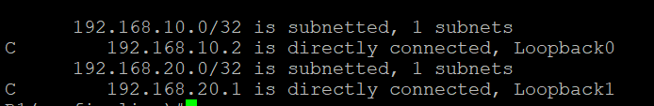

**R2:**

interface Loopback0

ip address 192.168.10.3 255.255.255.255

interface Loopback1

ip address 192.168.20.4 255.255.255.255

interface GigabitEthernet0/0/0

ip address 172.16.0.2 255.255.0.0

negotiation auto

interface GigabitEthernet0/0/1

ip address 192.168.0.1 255.255.255.0

negotiation auto

router ospf 109

network 172.16.0.2 0.0.255.255 area 0

network 192.168.0.0 0.0.0.255 area 0



**R3:**

interface Loopback0

ip address 192.168.10.1 255.255.255.255

interface GigabitEthernet0/0/0

ip address 10.0.1.2 255.255.255.0

negotiation autointerface

GigabitEthernet0/0/1

no ip address

router ospf 109

network 10.0.1.0 0.0.0.255 area 0

network 192.168.10.0 0.0.0.255 area 0



**R4:**

interface Loopback0

ip address 192.16.3.4 255.255.255.255

interface GigabitEthernet0/0/0

ip address 192.168.0.2 255.255.255.0

negotiation auto

interface GigabitEthernet0/0/1

ip address 192.168.30.1 255.255.255.0

negotiation auto

router ospf 109

network 10.10.13.0 0.0.0.3 area 0

network 192.168.0.0 0.0.0.255 area 0

network 192.168.30.0 0.0.0.255 area 0

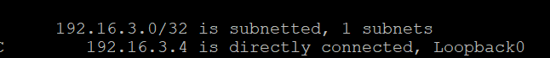

**R5:**

interface Loopback0

ip address 192.168.40.1 255.255.255.255

interface GigabitEthernet0/0/0   
no ip address shutdown   
negotiation auto  
interface GigabitEthernet0/0/1   
ip address 192.168.30.2 255.255.255.0  
negotiation auto   
router ospf 109   
network 192.168.30.0 0.0.0.255 area 0



**Problem Section:**

We initially had a tough time getting the router link lights to turn on but then we realized that both the router’s interface we were configuring had to be turned on and the router’s interface it was connected to also had to be on. We also had little knowledge on OPSF so it was challenging to understand what the OSPF area meant. Another challenge we had was we started the setup I used a /31 address and that led to problems as those addresses have 2 hosts which led to me having to change the configuration of some routers.

**Conclusion:**

We set up 5 routers to communicate with one another using OSPF. They all were connected to the same OSPF area and had individual ip’s for each connection. We ran into some issues with ip addressing on a router and turning on the router interfaces.